DEPARTMENT OF COMPUTER SCIENCE AND ENGINEERING

CSP67: MINI PROJECT WORK
TERM: Mar -June 2025

MINI PROJECT
A Cognitive Psychology Approach to Analyse Information in Social Network Using Machine Learning

Submitted to
Akshata S Bhayyar

TEAM MEMBERS

Sl. No | USN | Name
1 | 1MS22CS035 | Aryan Kumar
2 | 1MS22CS041 | Basavaraj Bhajantri
3 | 1MS22CS057 | Hariprasad B R
4 | 1MS22CS065 | I Suprabath Reddy

Table of Contents

Chapter No Content Page no

1 Design
1.1 Introduction 1
1.2 Architecture Design 1
1.3 User Interface Design 3
1.4 Low Level Design 5
1.5 Conclusion 8

DESIGN
1.1 Introduction
Social networks have become integral to modern communication, generating vast amounts of data that contain valuable insights into human behavior and psychology. This project aims to analyze social network information through a cognitive psychology lens using machine learning techniques. By combining principles from psychology with advanced data analysis, we seek to understand how users interact online, identify cognitive biases, detect misinformation, and analyze emotional patterns across social media platforms. Our modular layered architecture integrates data acquisition, preprocessing, analysis, chatbot interaction, and visualization components to provide meaningful insights into user behavior. The system is designed to classify users based on their cognitive profiles, detect various types of biases in content, analyze sentiment and emotions across different languages, and provide interactive visualizations for better understanding of the data. The memory-augmented chatbot adapts to individual psychological profiles, maintaining personalized interactions based on historical data. This interdisciplinary approach bridges the gap between technology and psychology, offering deeper insights into how information spreads and influences people on social media. The project addresses the growing need for more sophisticated tools to understand human behavior in digital spaces, especially considering the rapid spread of information and misinformation online. By leveraging machine learning algorithms alongside psychological frameworks, our system aims to provide a more nuanced understanding of social network dynamics.

1.2 Architecture Design
To enable advanced behavioral analysis, the architecture is built using a modular layered approach. It ensures separation of concerns across stages like data processing, psychological analysis, chatbot interaction, and visualization. This structure not only promotes maintainability and scalability but also facilitates seamless integration of cognitive models and machine learning algorithms for accurate and adaptive user insights.

1.2.1 Selected Architectural Style: Modular Layered Architecture
The Modular Layered Architecture is chosen to separate concerns in the system, enhance maintainability, and allow for easier scaling. Each layer handles a specific responsibility—from data acquisition to visualization—enabling better abstraction and modular development. This architecture is ideal for a data-driven project like ours, which incorporates psychological modeling, machine learning, and social network analysis.

1.2.2 Key Characteristics of Modular Layered Architecture
- Separation of Concerns:The application is divided into clearly defined layers such as Data Ingestion, Preprocessing, Analysis (ML/Cognitive), Interaction Layer (Chatbot), and Visualization. This ensures clarity and ease of development and testing.
- Scalability: Each layer can be independently scaled based on load. For instance, the analysis layer with deep learning models may require more computational resources and can be deployed on GPU-powered servers.
- Maintainability: As each module has distinct functionality, making changes to one component does not affect others. This facilitates quick iterations and upgrades.
- Reusability: Modules like the Cognitive Bias Detection or Language Processor can be reused across different projects with minimal changes.
- Extensibility: Future enhancements like integrating advanced LLMs or additional personality profiling models can be added without impacting the rest of the architecture

1.2.3 Components of the Architecture
Figure 1.1 illustrates the object-oriented class diagram of the system, highlighting
core modules such as UserProfile, AnalyzerEngine, MemoryChatbot,
LanguageProcessor, and VisualizationTool, along with their relationships.
- Data Acquisition Layer: Captures and stores social media data (posts, interactions, metadata) through APIs.
- Preprocessing Layer: Performs text normalization, tokenization, language detection, and cleaning.
- Analysis Layer: as follows
  - User Classification Module: Uses machine learning and reinforcement learning to dynamically classify users into cognitive psychology-based profiles.
  - Bias Detection Module: Identifies misinformation, emotional manipulation, and cognitive distortions.
  - Sentiment and Emotion Analysis: Detects mood, tone, and sentiment across languages using NLP and psychological heuristics.
- Chatbot Interaction Layer: A memory-augmented chatbot that adapts based on historical data and cognitive profiles to maintain personalized interactions.
- Visualization Layer: Presents data through interactive network graphs, emotional flow maps, and user classification dashboards.
- Database Layer: Stores raw data, processed features, user profiles, and analysis outputs using scalable storage like PostgreSQL or MongoDB.
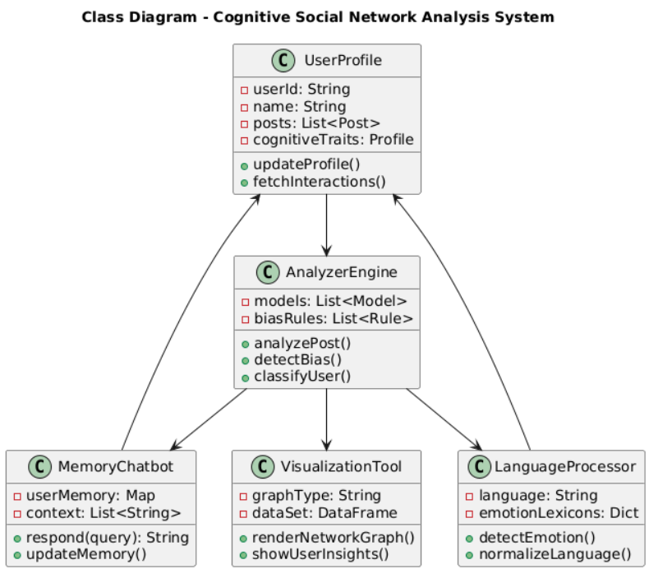
Figure 1.1 Class Diagram

1.3 User Interface Design
The User Interface (UI) of the Cognitive Psychology-Based Social Network Analysis System is designed to provide a clear, insightful, and accessible experience for analysts, researchers, and decision-makers. Given the complexity and sensitivity of analyzing human emotions, biases, and misinformation online, the UI emphasizes interactive visualizations, psychological transparency, and user-guided exploration of insights

1.3.1 Design Philosophy

Psychology-Centric: The system interface aligns with human psychological behavior by presenting emotionally intelligent cues, cognitive bias indicators, and sentiment-driven trends in a digestible manner.
- Data Scientist Friendly: It provides in-depth access to user classification models, sentiment progression, and misinformation propagation without overwhelming non-technical users.
- Responsive and Modular: Optimized for both desktop and mobile, supporting seamless usage across platforms in real-time analysis environments.
- Accessible to All: Inclusive design using readable fonts, high-contrast color schemes, multilingual support, and icon-based navigation to ensure usability across diverse audiences.

1.3.2 UI Layout Overview :The application is structured into the following core interface
- User Setting and Language Control
- Sentiment and Bias Analysis Feed
- Cognitive Chatbot Panel
- Social Network Visualizer
Each screen includes a consistent top navigation bar, central visual data panels, and a side or bottom panel for tools, export options, and real-time notifications.

1.3.3 Key Screens and Components: Following are the Components with explanation

Dashboard Overview :Displays high-level statistics: Total posts analyzed, misinformation rate, emotional polarity distribution. Shows trending cognitive biases (e.g., confirmation bias, groupthink).Visual timeline of sentiment shifts across user interactions
- Sentiment & Bias Feed ;Feed-style UI showing analyzed posts and comments. Each post is tagged with sentiment (e.g., joy, fear, anger) and cognitive bias flags.Real-time heatmap to visualize emotion spikes. Buttons: "Flag Misinformation", "Deep Dive", "Compare Trends".
- Cognitive Chatbot Pane:AI-powered memory-augmented chatbot. Tracks user emotional behavior over time. Responds to queries with psychological insight. Stores user logs for adaptive response patterns.
- Settings and Language Panel: Export data as CSV, JSON, or GraphML. Options to switch between English and one Indian language. Control cognitive bias detection sensitivity. Configure chatbot memory duration and alert levels.
1.3.4 Design Tools and Libraries
- Real-Time Engine: WebSocket + Flask-SocketIO
- Frontend Framework: React.js
- Visualization Libraries: D3.js, Chart.js
- Chat Layer: Rasa / Dialog flow for chatbot
- Styling: Tailwind CSS, Material UI

1.4 Low Level Design
The low-level design outlines the technical implementation details of our cognitive psychology-based social network analysis system. It maps the interactions and data flows within each module, connecting psychological principles with machine learning components. The accompanying diagrams visualize the processing sequences and state transitions necessary for developers to implement the system effectively.
1.4.1 Adaptive and Context-Aware User Classification
Figure 1.2 illustrates the Adaptive User Sequence Diagram, showing:
- Data Collection → Feature Extraction → Classification → User Profile Update flow
- Reinforcement learning module continuously adjusts weights based on prediction accuracy
- State tracking component differentiates between temporary states and stable traits
- Dynamic thresholds adapt based on individual user variance patterns
- Profile versioning system maintains history of cognitive/personality evolution
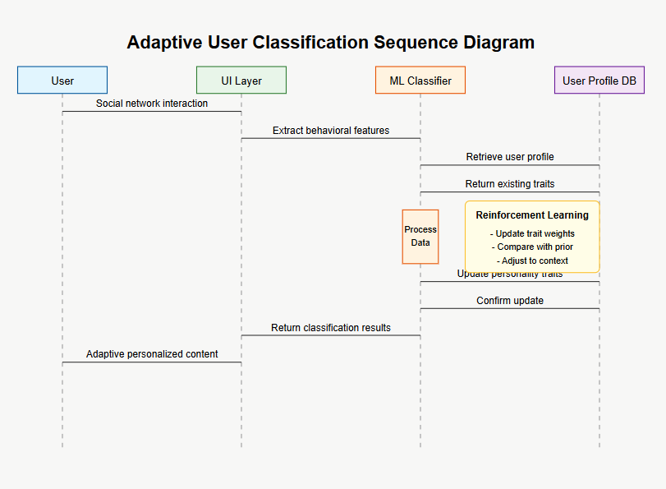
Figure 1.2 Adaptive user sequence Diagram
1.4.2 Cognitive Bias Detection and Reframing
Figure 1.3 depicts the Cognitive Bias Sequence Diagram, outlining:
- Input Analysis → Bias Detection → Technique Selection → Intervention Generation → Feedback Collection
- Pattern-matching against bias repository containing 25+ cognitive biases
- CBT technique selection based on bias type, user receptivity, and historical effectiveness
- Intervention generation using templated natural language with contextual adaptation
- Response tracking to measure effectiveness and refine future interventions
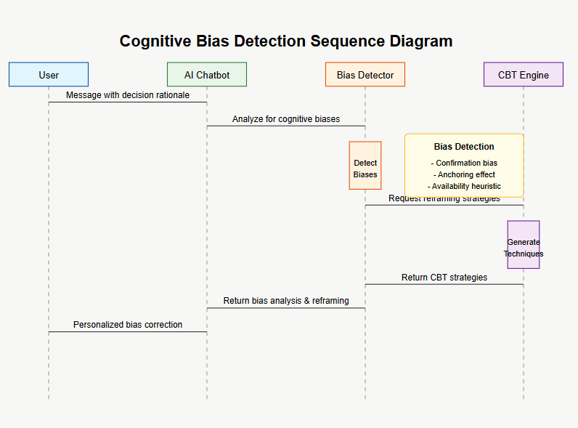
Figure 1.3 Cognitive Bias sequence Diagram
1.4.2 Memory-Enhanced Chatbot for Emotional Intelligence
Figure 1.4 shows the Memory-Enhanced Chatbot State Diagram
- Episodic memory module storing conversation history and emotional reactions
- Semantic memory module maintaining emotional baselines and pattern recognition
- Contextual state manager tracking current emotional trajectory
- Transition rules between neutral, positive, and negative emotional states
- Memory consolidation process that converts short-term interactions to long-term patterns
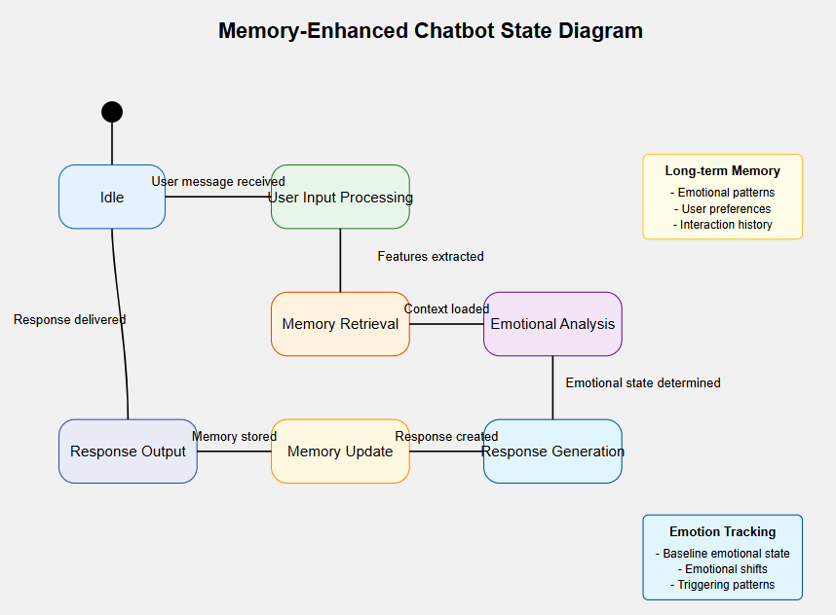
Figure 1.4 Memory-Enhance chatbot State Diagram

1.4.4 Cross-Linguistic Emotion Recognition
Figure 1.5 presents the Cross-Linguistic State Diagram Featuring:
- Language identification → Cultural context loading → Semantic analysis → Emotion mapping
- Language-specific emotional intensity calibration for accurate cross-cultural comparison
- Contextual modifier system adjusting for situational norms across cultures
- Bilingual emotional expression analyzer detecting code-switching patterns
- Adaptive sentiment threshold system that recalibrates based on language and context
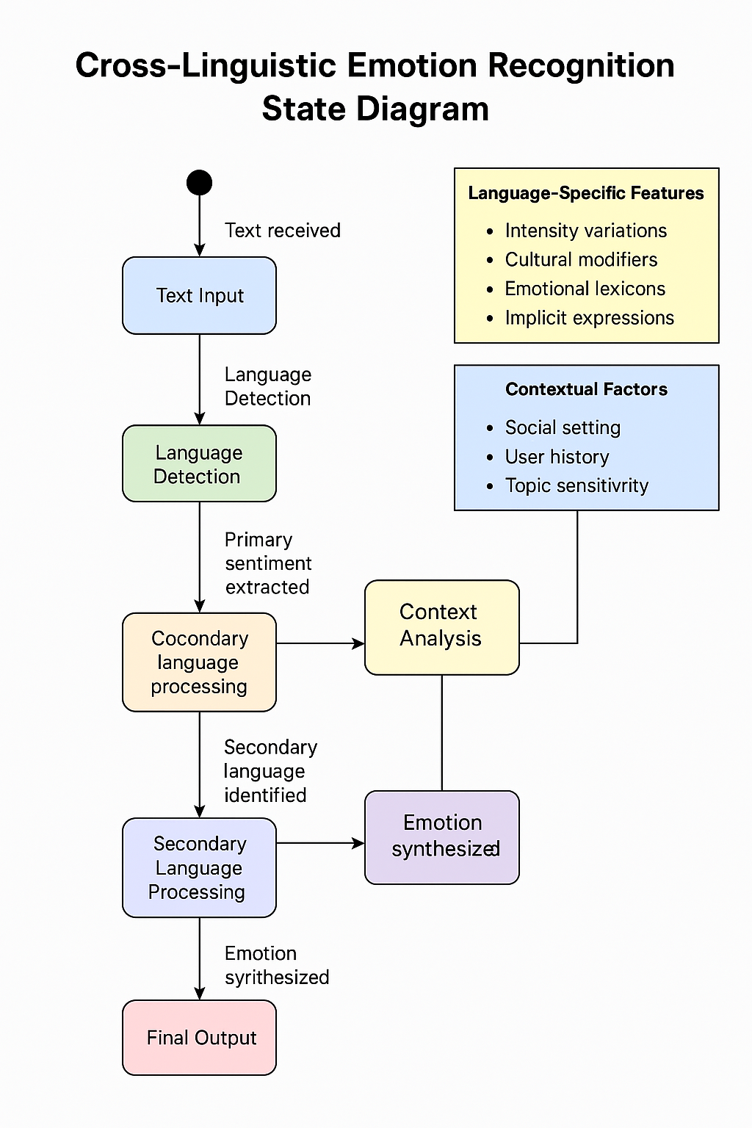

Figure 1.5 Cross-Linguistic State Diagram

1.5 Conclusion
This project successfully demonstrates the integration of cognitive psychology principles with machine learning techniques to analyze social network information. Our modular layered architecture effectively processes social media data through various stages—from acquisition and preprocessing to analysis and visualization—enabling comprehensive understanding of user behavior patterns, cognitive biases, and emotional expressions. The memory-enhanced chatbot and adaptive user classification provide personalized insights that evolve over time, while the cross-linguistic emotion recognition capabilities ensure analysis across diverse cultural contexts. These features collectively offer valuable tools for researchers, analysts, and decision-makers to understand psychological aspects of social media interactions. The system's ability to identify cognitive biases and misinformation helps address critical issues in today's digital information ecosystem. Our user interface design emphasizes psychology-centric visualization, making complex psychological data accessible to both technical and non-technical users. The implementation of reinforcement learning enables the system to continuously improve its classification accuracy and adapt to changing user behaviors. The cross-linguistic capabilities make the system particularly valuable in diverse cultural contexts like India, where multiple languages are used on social platforms. As social networks continue to evolve, this system provides a foundation for more nuanced understanding of human behavior online, with potential applications in misinformation detection, emotional wellbeing analysis, and personalized digital experiences. Future work could expand the system to incorporate more advanced psychological models and additional language support to further enhance its analytical capabilities

Signature of the Guide

